Reporting Period: | 1 July 2013 – 30 September 2013

Development Partners: | Donors: Government of Japan  Implementing Partner(s): Social Fund for Development & Local Administration Reform Unit  Modality: NEX

Background
UNDP Egypt supports its longtime partner, the Social Fund for Development (SFD) in the design and implementation of labor intensive public work projects. The program aims to respond to the urgent need to create short term employment in social services and infrastructure works as well as to build capacities and skills of Egyptian unemployed youth (19-29 years of age), especially in rural area in response to the current economic crisis. Based on Rapid research and development activities and community appraisal and consultations embedded in broader Local Economy Assessments that took place in the first Phase, it implements social services and labor intensive public works programs in different sectors to expand and diversify employment opportunities for both young men and women.
The number of short term employment opportunities for youth (ages 18 to 29) created since the starting of Phase I in 2012 in Social Services projects (maternal and child health initiatives as well as cleanliness environmental campaigns) and in Public Work projects reached 343.800 person-days by the End of September 2013.
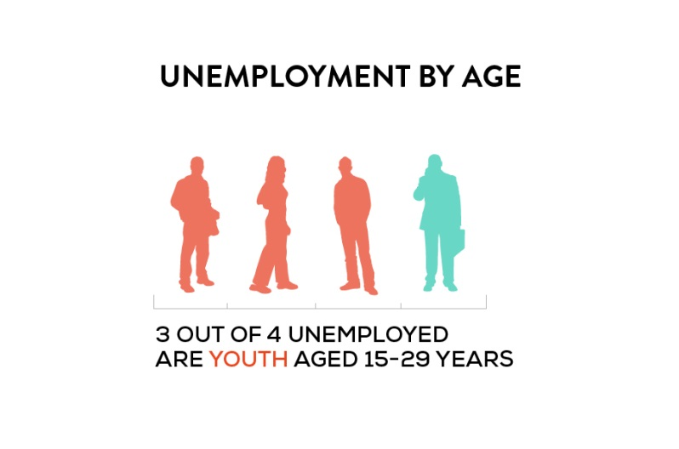
The project will be implemented in two of the poorest governorates (Fayoum and Sohag), since youth unemployment has a significant rural dimension and since 62% of Egyptian youth live in rural areas.
- It was estimated that 3.6 million Egyptians were unemployed during the second quarter of 2013 (equivalent to 13.3 % of the total labour force).
- Youth (i.e. 15-29 years old) bear a disproportionate share of the jobless rate constituting 73.9% of the unemployed of the 13.3% overall rate.

Objectives
- Local Economic Development institutional arrangements, tools and mechanisms established and adopted at the national level and in two of the poorest governorates.
- Short and medium term employment opportunities for youth, in public works programs, created in the poorest governorates.

Achievements
Output 1: Local Economic Development Institutional Arrangements, tools and mechanisms established and adopted at the national level and in two of the poorest governorates.
It was planned that under this phase, the programme will build on efforts already made in the first Phase and will further strengthen the institutional arrangements and develop the procedures and capacities that are critical to conducting an integrated LED promotion effort at the national and local levels.
In light of the recent events in Egypt that led to the cabinet change in July 2013 and the further deteriorating economic situation with unemployment rates still on the raise, it was decided that the funds that were initially allocated under Output 2 will be spent to implement additional public works projects that are labor intensive and will create jobs for youth while improving the infrastructure and the quality of life. The Minister of Local Development initiated a series of meetings between MoLD, SFD and UNDP to reallocate the funds to SFD The Government of Egypt and UNDP consider that tackling youth unemployment is a top priority that contributes to stabilizing the on-going transition and that it is important to create jobs in a fast-track modality.
Allocating the funds of Output 1 to Output 2 will provide a higher number of immediate jobs and skills development opportunities, thus benefiting the most vulnerable and marginalized through the provision of income and increasing future employability prospects.
Although the outputs are amended, the project is still fully in line with the project document with regard to creating job opportunities for unemployed youth in Egypt, addressing the immediate needs of the Egyptian people.
SFD is currently finalizing the contract with the Governor of Sohag, introducing additional activities for the amount of USD 1,033,645, initially allocated for Output 1. SFD has the needed capacities to carry out the additional work within the given timeframe of the project.
It is to be noted that under the Local Economic Development Output in Phase 1 as well as Phase 2 valuable results were achieved. Through the implementation of LED processes, the local teams of the Local Administration Reform Unit (LARU) identified a catalogue of priority economic development infrastructure projects (See Output 2) that will be implemented in Phase II. (See Output 2)

Output 2: Short and Medium term employment opportunities for youth, in public works programs, created in Fayoum and Sohag governorates.
Public Work Projects that were identified during the pilot phase through implementation of LED processes, assessment of local economic contexts, stakeholder’s consultation and the local economic strategy formulation will be implemented under this output. Based on initial analysis results generated through the Local Economy and Business Assessment (LEBA), feasible projects meeting the SFD labour criteria were identified:

- Fayoum Governorate :
An Integrated Development Project was signed with the Governor of Fayoum on 17/9/2013. 60 sub-projects with an overall budget of 14 million L.E. (equal to 2 million USD) will be implemented. The project includes replacement and renewal of potable water networks, paving rural roads, and creating and developing markets. The total number of job opportunities that is planned to be created in Fayoum through the project is 55,598 person-days.
- Sohag Governorate :
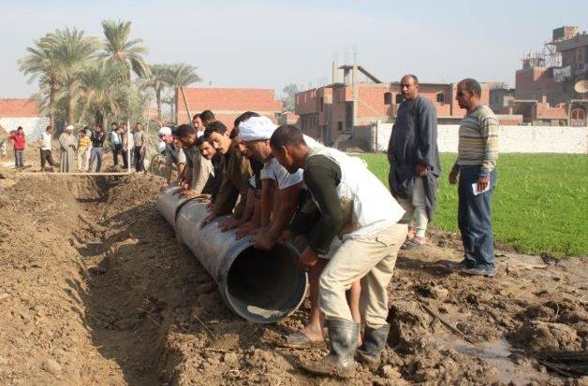
An Integrated Development Project with a budget of 22 million L.E. (equal to 3.14 million USD) was prepared for the Governorate of Sohag governorate. The project includes replacement and renewal of potable water networks, paving rural roads, canal coverage and establishing veterinary units through implementing 30 sub-projects. Total number of job opportunities that is planned to be created in Sohag through the project is 71,678 person-days.

Cross-cutting Issues
- Poverty reduction and building more resilient communities: Because of this integrated planning process, which takes into account the available local resources, the local community is more resilient to absorb economic and financial shocks.
- Building food security as it is strongly interlinked with sustainable local economic development and trade.

Challenges and Lessons Learned
Challenges:
- The office of the LED in Fayoum Governorate has been burned down during the escalating unrest that the country witnessed in August 2013. Fortunately no one was in the office when the attack happened. The functional and operational capacity of the office was limited for a short period of time. The negative impact of the events was minimized, inter alia, due to the full back-up of the Governor in Fayoum who provided the team with a temporary office.
- Current volatile political situation which implies a high turnover rate of key persons on ministerial, governorate and local level and limited mobility in certain areas such as Cairo and several governorates.
- In addition, the Egyptian economy still faces key economic and social challenges. The slowdown in economic activities leads to increased official unemployment rates.
Lessons Learned:
- The first phase of the project implemented infrastructure and social work projects in 6 governorates. Under Phase II the project will concentrate on 2 governorates. One lesson learned in this regard is, that the results for the community in the targeted localities will be more tangible if the project focusses on less governorates. Furthermore, the project concentrates on two Governorates in Upper Egypt, where unemployment rates and economic deprivation are highest.
- Although the project faced several political challenges in July and August 2013, the project management succeeded in minimalizing the impact on the project in order to maintain the goals and deadlines. As shown above, necessary adjustments to the workplan were made in order to fulfill the project mandate and to meet the needs of the most v. In addition, the amendment of the project work plan will increase the number of beneficiaries, both young men and women, while at the same time infusing infrastructure and service investments much needed to boost local economic development in poor communities.

Key Partnerships and Inter-Agency Collaboration
The work done so far was through effective collaboration among SFD, LARU/MLD and the Fayoum and Sohag governorates' staff of the respective implementing partner. UNDP played a significant and supportive role in brokering this three partite partnership and in facilitating key coordination meetings between SFD and LARU.
On September 19th, 2013, the contract for Fayoum Governorate was signed in Cairo by the Managing Director of the Social Fund for Development Mrs. Ghada Waly and the Governor of Fayoum, Mr. Hazem Ahmed Attia. The Ceremony was attended by Embassy of Japan Representative Mr. Naofumi Hashimoto, the Prime Minister Mr. Hazem El Biblawy, the Minister of Local Development Mr. Adel Labib and UN Resident Coordinator and UNDP Resident Representative Mrs. Anita Nirody.
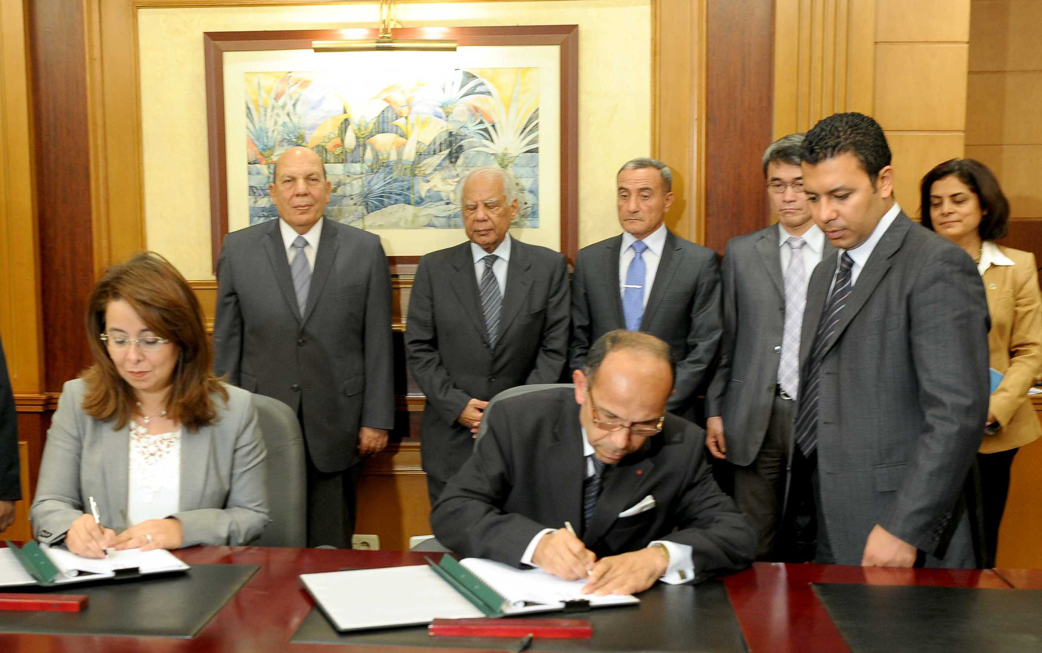
The ceremony was attended and covered by Egyptian media.

Way Forward
- Start the preparatory activities for Fayoum project, complete the engineering design, the bidding documents, the prequalification of local contractors, start the procurement procedure, evaluation committees, awarding of civil works sub projects to local contractors, start construction activities of infrastructure sub projects.
- Present the project document for Sohag's project to the SFD appraisal committee.
- Finalize and sign the Frame work agreement with Sohag Governorate, the Signing Ceremony is scheduled for the first week of November 2013.

Resources and Financial Status
- The contribution of Government of Japan for the project (2013-2014) is 5,600,000USD.
Budget Breakdown
Award #: 00049150  Project #: 00085907 | Overall Budget | April – December  2013 | Jan – March 2014
Output 2 | 5,233,645 | 1,000,000 | 4,233,645.00
F&A | 366,355 | 70,000 | 296,355
Total | 5,600,000 | 1,070,000 | 4,530,000
Delivery Rate |  | 19% | 81%

Expenditures 2013 as of 1.10.2013
Award #: 00049150  Project #: 00085907 | Approved Budget | Expenditures | Advances and Commitments | Remaining Budget
Output 2 | 1,070,000 | 2,400 | 911,630 | 155,1970

It has to be noted that the delivery rate for this project is low in the starting-up period of the project due to the nature of the activities. In the preparatory phase feasible projects have to be identified and approved. Until the contracting of companies who will implement the labor intensive public work, SFD relies on its own resources when carrying out the activities (see achievements and next steps). In conclusion, the low delivery rate after the second quarter of the project is as foreseen and planned.

Please refer to the progress reports of Phase I for more information.
For more info please consult progress reports of Phase I.
UNDP transferred USD 900’000 to the Project as advances. The advances will be settled upon receipt of the financial report submitted by the project in the 4th quarter of 2013. As such, when calculating the delivery rate, the advances should be taken into account.

